SPOOFING DETECTION FOR FINGERPRINT, PALM-VEIN AND FACIAL RECOGNITION USING DEEP REPRESENTATION

¹Mr. R. Augustian Isaac, ²Aditya Kathera, ³K.H. Venkatachalam, ⁴Moturu Tarun Raj, ⁵G.Gokulnath

¹Assistant Professor (S.G), Department of Computer Science and Engineering,
SRM Institute of Science and Technology, Chennai, Tamil Nadu, India

^{2.3.4.5}Student, Department of Computer Science and Engineering,
SRM Institute of Science and Technology, Chennai, Tamil Nadu, India

Abstract — The authentication scheme is a crucial science mechanism, through which two communication parties might attest one another within an open network setting. To satisfy the necessity of sensible applications, several authentication schemes, strong passwords and good cards are projected. However, passwords may be disclosed or forgotten, and good cards may be shared, lost, or stolen. In difference, biometric strategies, like face, fingerprints or palm vein scans, do not have any such drawbacks. For the system, three biometric traits are collected and are stored in the server at the time of registration. The Multimodal biometric based systems are extremely secure and are economical to use. These systems are sometimes vulnerable to wordbook attacks initiated at the server end. In this paper, we propose a Spoofing detection model for finger print, palm vein and facial recognition biometric identification for user authentication and key exchange system. In this system, we extract the texture property area unit from the palm vein, finger print and face images and are stored as encrypted binary guide within the user’s information, to prevent the wordbook attacks mounted by the server. The image processing technique helps to extract a biometric measurement from the palm vein, finger print and face. Throughout the login process a mutual authentication is performed between the server and user end. The feature value generated is matched with that of the database images feature value and thus identifies if any spoofing occurs. This technique also prevents any meet-in-the middle attack that happens between the user and the server.

Index Terms - Face, Palm-vein and Finger Print Recognition, Face, Palm vein and Finger Print Identification, GLCM Features, Neural Network Classification.

- INTRODUCTION

Biometric identification, identifies the external body part in recordings and computerized photos, and compare it with the ones existing in the system to authenticate any human. The advancement in this technology has been put to use in multiple areas, for instance, human - laptop Interfaces, Security Systems, closed-circuit television, content primarily based Image Retrieval. Henceforth this demonstrates the importance of face, palm vein and finger print identification in the field of biometrics. Generally, a face recognition, palm vein recognition and finger print recognition framework can primarily differentiate and analyze an image categorizing it based on its features namely, shape, color and texture.

The goal of our work is to differentiate and acknowledge covering confronts as, face, Palm vein and finger print that lie or reaches out over and covers some portion of any other face, palm vein and finger print, in the image. Whenever at least two appearances are overlapped, it differentiates the parameters severally utilizing the standard biometric identification ways. The proposed methodologies can identify the multiple angles of the input images and further compare the pixel value of each position with the central position pixel value. For instance, in face, palm vein and fingerprint recognition; if any skin shading or spoofing approach has been performed the existing model will fail to identify it. The suggested method will detect and any false spoofing and with the help of neural networks it will identify the authenticity of the image.

In this paper we propose a NSCT transform and GLCM feature extraction to detect face, palm vein and finger print in the input and database images. The feature extraction method first identifies the face using RGB color model and further divides the face region into blocks of equal size, and extracting the face features using GLCM. Subsequently, the Neural Network classification method is used to categorize the face, palm vein and finger print images as authentic or unauthentic.

2. REVIEW OF LITERATURE

Face form is additionally vital information for glasses style firms. During this paper, we tend to plan a non-contact technique to classify the face form by victimization Support Vector Machine (SVM) technique. This algorithmic rule consists of three steps: head segmentation, face plane identification, and face form classification. First, as the whole 3D body information is captured and used as input by the system, Eigen vector is employed to outline frontal facet. Chin-Neck junction, Ellipsoid Fitting Technique and Mahalanobis distance are combined as a head phaseation algorithmic rule to segment the 3D head. Second, face form may be discovered once projected on a plane. Major axes of ellipsoid are accustomed outline a plane on the pinnacle referred to as the face plane. Face form on the face plane is assessed into four categories in third step. To check the performance of the planned technique, ninety subjects are used. SVM is employed to classify the face form into four teams. The four form of the face form are oval form, long shape, form, and square shape. The accuracy rate is seventy three.68%. The result shows the feasibleness of the planned technique. a bonus of this technique is that this technique is initial totally automatic and non-contact face form classification for whole 3D physical structure information. [1]

A compact and reliable room attending system victimization RFID and face verification is presented during this paper. The RFID system identifies the student victimization the RFID card and any identification of the student is applied victimization face recognition technique. RFID unambiguously identifies the scholar supported the cardboard variety, then a personal (Fast adaptation Neural Network Classifier - FANNC) classifier is employed to verify the face of every student solely. The system is trained and tested by conducting experiments on FEI face information. Every classifier is trained victimization face pictures of every student in seven totally different head poses and it's tested against six different poses. The performance of the system is tested for frontal face verification, head create varied face verification and detection of proxy attending is applied. It’s found that the projected theme verifies the identity of the scholar properly of concerning 98 for frontal face and 2 makes an attempt on poses varied face verification. The proxy attending detection applied for frontal face resulted in Associate in nursing potency of 73.28% Associate in Nursing for various poses resulted in a potency of 79.29%. [3]

Face recognition is that the core application within the biometric technology space. It’s wide employed in the advanced application of artificial intelligence and laptop vision. Raising business of face recognition and low social control makes a call for participation of it will increase within the last decade. During this paper, we have a tendency to present state of the art of in face recognition technologies by that specialize in some ancient problems and a few techniques to treats these issues. The advantage of instructed algorithmic rule is to unravel the favored problems in face recognition like light-weight conditions and environmental factors that cause the low-performance. In projected algorithmic rule, teams of edge detection filters (Sobel, Prewitt, and Roberts) were wont to extract edges of the faces in pictures. Differential coefficient edge detection filters were performed to induce best options of knowledge set. Moreover, victimization edge detection method that employed by first order filter is to scale back knowledge the maximum amount as possible by removing image background. The new technique used as feature extractor addition to ancient PCA. Gathering options by victimization slope technique and PCA is to search out the optimum faces vectors because the inputs to the classifier (NNMLP neural network). Results have unconcealed acceptable correct classification. As knowledge check set we have a tendency to used BIO-ID knowledge base within the projected system. [9]

3. block diagram
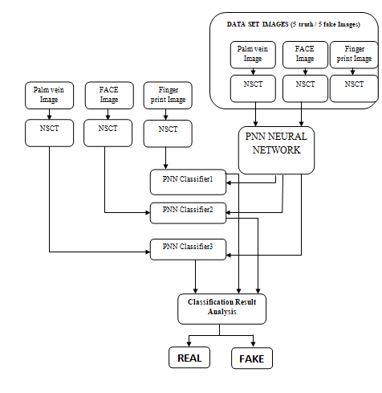
Fig.1: Block diagram of Spoofing detection

4. SYSTEM ANALYSIS

1. Input image
2. Database creation
3. Preprocessing
4. NSCT Transform
5. GLCM Feature Extraction
6. Neural Network Classification
7. Result

  - PREPROCESSING

Image pre-processing is the term used for operations on images like changing a RGB image to a grayscale image by adjusting the resolution of the image as needed. The image information content is not increased by the operations performed but they are decreased if the entropy is associate degree metric. The aim of pre-processing is associate degree improvement of the image information that suppresses unwanted distortions or enhances some image options relevant for more process and analysis task. The process of plane separation occurs on Red / Blue / Inexperienced.

  - GLCM FEATURES EXTRACTION

This process creates a GLCM, with the help of gray co-matrix function. The function creates a gray-level co-occurrence matrix (GLCM) by computing the number of times a pixel with the intensity (gray-level) value i occurs in a specific spatial relationship to a pixel with the value j. Each element (i,j) in the resultant GLCM is commonly the sum of the number of times that the pixel with value i occurred in the specified spatial relationship to a pixel with value j in the input image. The number of gray levels in the image determines the size of the GLCM. By default, gray co-matrix uses scaling to reduce the number of intensity values in an image to eight, however you can use the Num levels and the Gray limit parameters to control the scaling of gray levels. GLCM has certain properties about the spatial distribution of the gray levels in the texture signals.
For example, the GLCM is concentrated along the diagonal and texture is coarse with respect to the specified offset in GLCM. can also derive stoical measures and the derive statistics from GLCM and more information from plot correlation as show in the following figure.
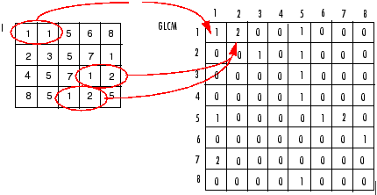

4.3. NSCT
The construction projected during this paper is predicated on a non-subsampled pyramid structure and non-subsampled directional filter banks. The result is a versatile multi-scale, multi-direction, and shift-invariant image decomposition that may be expeditiously enforced via the à trous rule. At the core of the projected theme is that the non-separable stereophonic non-subsampled filter bank (NSFB). We tend to exploit the less demanding style condition of the NSFB to style filters that cause a NSCT with higher frequency property and regularity when put next to the contour let rework. We tend to propose a style framework supported the mapping approach, that permits for a quick implementation supported a lifting or ladder structure, and solely use one-dimensional filtering in some cases. Additionally, our style ensures that the corresponding frame elements are regular, symmetric, and also the frame is near a decent one. We tend to assess the performance of the NSCT in signal de-noising and sweetening applications. In each application the NSCT compares favorably to different existing strategies within the literature. Our planned transform will so be divided into 2 shift-invariant parts: 1) a non-subsampled pyramid structure that ensures the multi-scale property and 2) a non-subsampled DFB structure that provides directivity.

4.3.1. Non-subsampled Pyramid (NSP)
The multi-scale property of the NSCT is obtained from a shift-invariant filtering structure that achieves a sub-band decomposition same as that of the laplacian pyramid. This can be achieved by victimization two-channel non-subsampled 2-D filter banks. Fig. 2 illustrates the planned non-subsampled pyramid (NSP) decomposition with J=3 stages. Such growth is conceptually like the one–dimensional (1-D) NSWT computed with the à trous formula and has J+1 redundancy, wherever denotes the amount of decomposition stages. The best pass band support of the low-pass filter at the jth stage is that the region . Consequently, the best support of the equivalent high-pass filter is that the complement of the low-pass, i.e., the region the filters for accompanying stages square measure obtained by up-sampling the filters of the primary stage. This offers the multi scale property while not the necessity for added filter style. The planned structure is therefore completely different from the severable NSWT. Particularly, one band pass image is created at every stage leading to J+1 redundancy. Against this, the NSWT produces 3 directional pictures at every stage, leading to 3J+1 redundancy. The 2-D pyramid planned is obtained with a similar structure. Specifically, the NSFB of is constructed from low-pass filter. One then sets, and therefore the corresponding synthesis filters. An analogous decomposition may be obtained by removing the down samplers and up samplers within the Laplacian pyramid so up sampling the filters consequently. Those excellent reconstruction systems may be seen as a specific case of our additional general structure. The advantage of our construction is that it's general and as a result, higher filters may be obtained. Particularly, in our style and square measure low-pass and high-pass. Thus, they filter sure components of the noise spectrum within the processed pyramid coefficients.

4.3.2. Non-subsampled Directional Filter Bank (NSDFB):

The directional filter bank is built by combining critically-sampled two-channel fan filter banks and resampling operations. The result's a tree-structured filter bank that splits the 2-D frequency plane into directional wedges. A shift-invariant directional enlargement is obtained with a non-subsampled DFB (NSDFB). The NSDFB is built by eliminating the down samplers and up samplers within the DFB. This can be done by shift off the down samplers/up samplers in every two channel filter bank within the DFB tree structure and up sampling the filters consequently.

This leads to a tree composed of two-channel NSFBs. within the second level, the up sampled fan filters have checker-board frequency support, and once combined with the filters within the first level provide the four directional frequency decomposition. The synthesis filter bank is obtained equally. Rather like the critically sampled directional filter bank, all filter banks within the non-subsampled directional filter bank tree structure square measure obtained from one NSFB with fan filters. Moreover, every filter bank within the NSDFB tree has an equivalent procedure quality as that of the building-block NSFB.

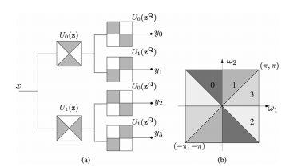
Fig.2: Four-channel non-subsampled directional filter bank constructed with two-channel fan filter banks.

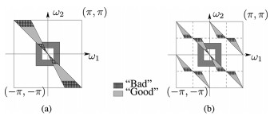

Fig.3: Need for up sampling in the NSCT

4.3.3. Combining the Non-subsampled Pyramid and Non-subsampled Directional Filter Bank in the NSCT:
The NSCT is made by combining the NSP and also the NSDFB. In constructing the NSCT, care should be taken once applying the directional filters to the coarser scales of the pyramid. Attributable to the tree-structure nature of the NSDFB, the directional response at the lower and higher frequencies suffers from aliasing which might be a haul within the higher stages of the pyramid. Wherever the pass band region of the directional filter is labeled as “Good” or “Bad.” Thus, we tend to see that for coarser scales, the high-pass channel in impact is filtered with the unhealthy portion of the directional filter pass band. This leads to severe aliasing and in some ascertained cases a substantial loss of directional resolution.

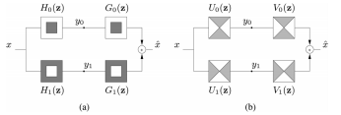

Fig.4: Two-channel NSFBs used in the NSCT

4.4. NEURAL NETWORK
The performance of the Probabilistic Neural Network (PNN) was evaluated in terms of coaching performance and classification accuracies. Probabilistic Neural Network offers quick and correct classification and could be a promising tool for classification of the cancer. The PNN with FF is trained with reference options set and desired output exploitation ‘newff’ and ‘train’ commands. Here, target one for dataset; two for dataset2 and dataset3 area unit are taken as desired outputs. Once trained, updated weight issue and biases with alternative network parameters area unit hold on to simulate with input options. At the classification stage, take a look at image options area unit utilized to simulate with trained network model exploitation ‘sim’ command. Finally, it returns the classified price as one, two or three supported that the choice going to be taken is real or fake.

ADVANTAGES

- Detecting accuracy is high due to extracting features of the image.
- Light pixels are high and dark pixels are low.
- Contour let transform coefficient requires only two bytes to store each of the extracted coefficients.
- The cancellation of the division in subtraction results avoids the usage of decimal numbers while preserving the difference between two adjacent pixels.
- This system gives more security compared to unit-modal system because of two biometric features

APPLICATION

- Bio-metric application.

5. RESULT AND DISCUSSION
In the existing system, we are using two databases one is the input database and the other is storage database. In this technique we are using DWT Transform Gabor filter with which we can calculate the individual face, palm vein and finger print and mark the key points and further apply LBA feature extraction to get the output. The output result has 75% accuracy. While in our proposed system, we use the detecting methods for face, palm vein and finger print using NSCT, GLCM features and Neural Network classification to get the output. The output result projects 95% accuracy.

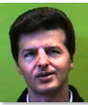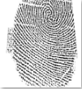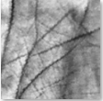
Fig.5: Input Image

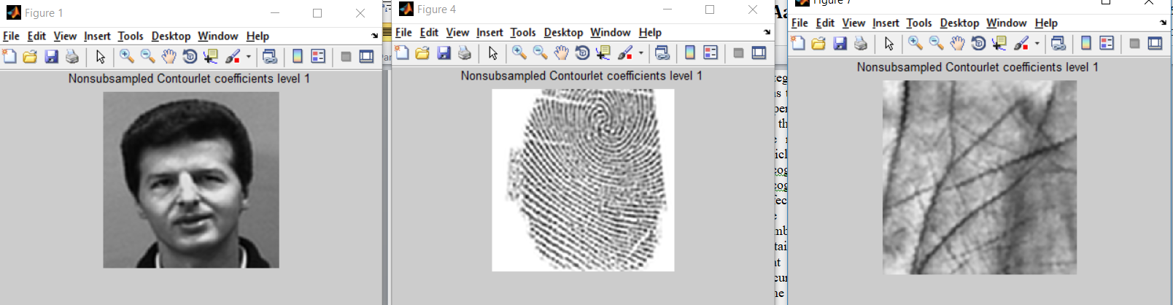

Fig.6: Result of NSCT Level-1 Transform

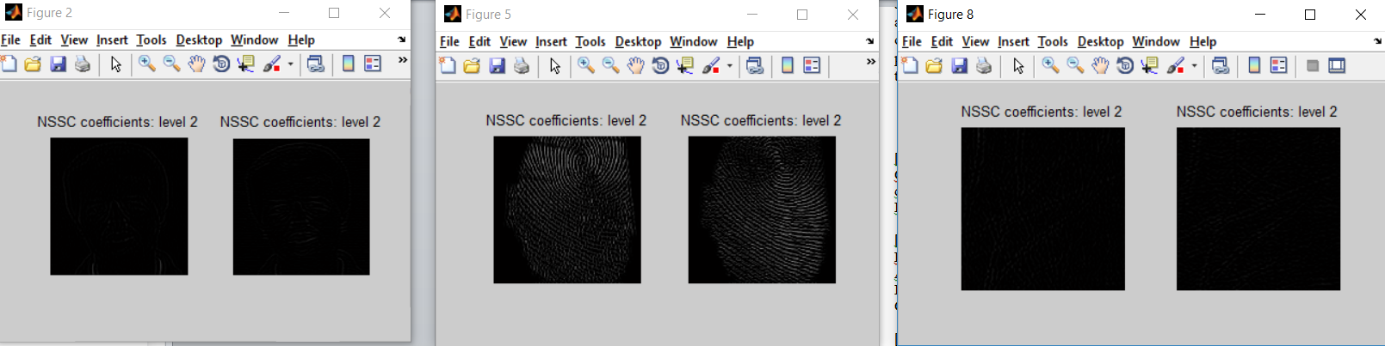

Fig.7: Result of NSCT Level-2 Transform

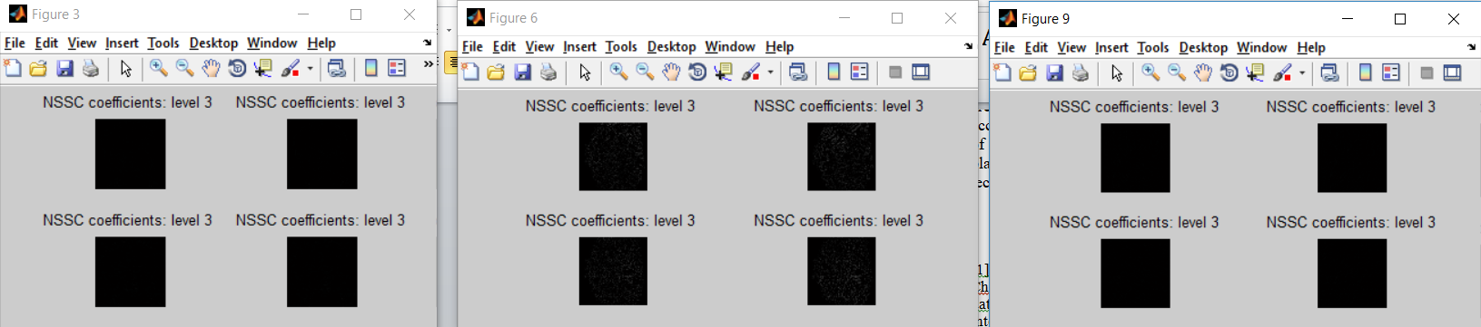

Fig.8 Result of NSCT Level-3 Transform

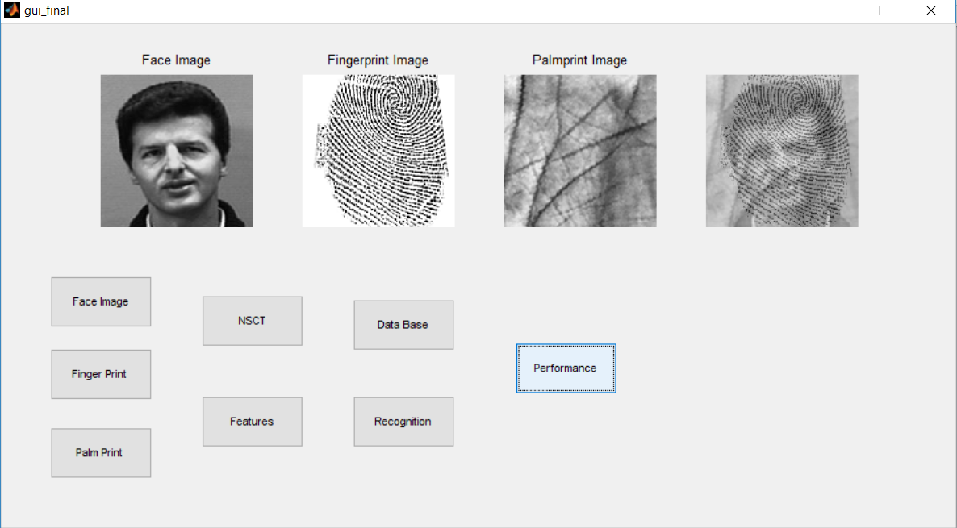

Fig.9: Result of Proposed System

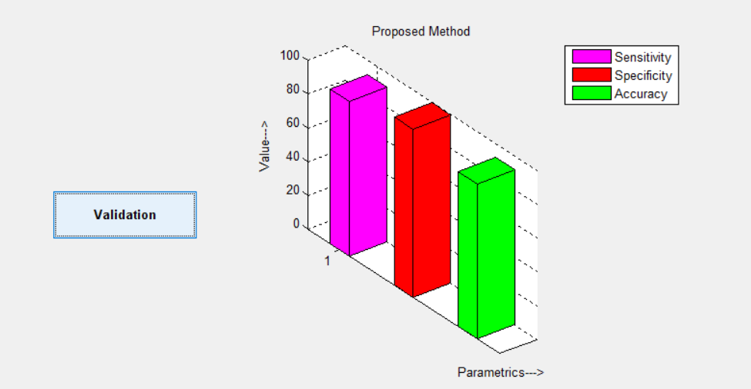
Fig.10: Performance Parameters

6. CONCLUSION

In our proposed technique we recognize face, palm vein and finger print by classifying them into a pair of categories. The strategy introduced during this article was tested on the JAFFE information which incorporates 5 persons. The information consists of ten pictures. 70% of the information was used for training and the remaining 30% for testing pictures. During this article, a replacement approach is introduced for facial recognition, palm vein recognition and finger print recognition and has extraction. First, area unit as effective in facial, palm vein and finger print recognition are determined on the person’s images. Subsequently, symbolic logic is used to classify the result. The results obtained from the simulation of this technique indicate that the planned technique, besides increasing the accuracy of biometric authentication and reducing the time required for this operation by choosing effective areas of the face, palm vein and finger print. The accuracy of the planned system is compared with different ways. It might be seen that the popularity of planned technique performs higher than the opposite technique.

6. REFERENCES

[1] Pornthep Sarakon, Theekapun Charoenpong and Supiya Charoensiriwath, “Face shape classification from 3D Human data by using SVM”, The 2014 Biomedical Engineering International Conference (BMEiCON-2014).

[2] Nirmalya Kar, Mrinal Kanti Debbarma, Ashim Saha, and Dwijen Rudra Pal. "Study of Implementing Automated Attendance System Using Face Recognition Technique". Information Technology Interfaces (ITI), 2010 32nd Global Conference on. IEEE, 2010.

[3]Srivignessh pss,Bhaskar .M "RFID & Pose Invariant Face Verification Based Automated Classroom Attendance System" international conference IEEE. 2016.

[4] M. Ahmady, R. Ghasemi, “Local Weighted Pseudo Zernike Moments and Fuzzy Classification for Facial Expression Recognition”, 2013 13th Iranian Conference on Fuzzy Systems (IFSC).

[5] XiningWang#1, Yu CAI#2, and M. Abdulghafour “A comprehensive Assessment System to Optimize the Overlap in DCT-HMM for Face Recognition” 2015 11th International Conference on Innovations in Information Technology (IIT) 2015 IEEE

[6] R.B. Kuriakose H.J. Vermaak “Developing a Java based RFID application to automate student attendance monitoring2015 Pattern Recognition Association of South Africa and Robotics and Mechatronics International Conference (PRASA-RobMech) Port Elizabeth, South Africa, November 26-27,2015 IEEE.

[7] M .Slavkovic.”Face Face Recognition using Gabor Filters,PCA & Neural Networks” . 978-1-4799-0944-5/13/$31.00 ©2013 IEEE

[8] WEI ZHA01. “Fually Automated Face Detection & Facial Feature Extraction using Local Gabor Filter Point “978·1·4577 ·0308-9/11/$26.00 ©2011 IEEE

[9] Abdulbasit Alazzawi; Osman Nuri Uçan; Oğus Bayat

“Face recognition based on multi features extractors“2017 International Conference on Engineering and Technology (ICET)

Authors
Mr. R. Augustian Isaac is an Assistant Professor in the Deaprmtent of Computer Science and Engineering at SRM Institute of Science and Technology. His research interests are centered on Service Oriented Architecture, Web services, Cloud services and Software Engineering.
Aditya Kathera is a final year student in the Computer Science and Engineering department at SRM Institute of Science and Technology. He has also pursued Certified Ethical Hacker (CEH), Computer Hacking Forensic Investigator (CHFI), EC-Council Certified Security Analyst (ECSA) certifications offered by the EC-Ccouncil.His research interests are centered on Cybersecurity, Cyber Forensics and Artificial Intelligence.

K.H. Venkatachalam is a final year student in the Computer Science and Engineering department at SRM Institute of Science and Technology. His research interests are centered on Cybersecurity and Artificial Intelligence.

Moturu Tarun Raj is a final year student in the Computer Science and Engineering department at SRM Institute of Science and Technology. His research interests are centered on Cybersecurity and Cloud Computing.

G.Gokulnath is a final year student in the Computer Science and Engineering department at SRM Institute of Science and Technology. His research interests are centered on Cybersecurity and Computer Graphics.

